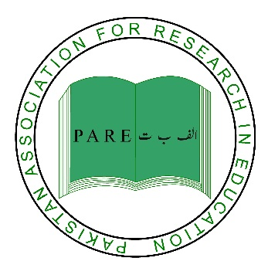

**Workshop on: “Writing For Publication In Education”**

May 28th, 2016

**REGISTRATION FORM**

**Note:** Mandatory fields are marked with*

|  |  |
| --- | --- |
| **Name**\* |  |
| **Designation**\* |  |
| **Institution**\* |  |
| **Mailing Address** |  |
| **City**\* |  |
| **Country**\* |  |
| **Tel** |  |
| **Fax** |  |
| **Mobile** |  |
| **E-mail**\* |  |

Deadline for the registration: May 21, 2016

Please contact undersigned for further details:

**Alizain Nizar Ali**

Programme Officer, PARE

Aga Khan University Institute for Educational Development

IED-PDC,1-5/B-VII,F.B.Area, Karimabad, P.O. Box 13688, Karachi - 75950

Phone: 36347611-4 & 36826991-4 Ext:8592

Email: [pare.secretariat@aku.edu](mailto:amirali.noorani@aku.edu)